How to Use an Ammeter

Current is one of the most important quantities that we would like to measure in an electric circuit. A devise that measures current is called an ammeter. The current to be measured must pass directly through the ammeter. This means that the ammeter is connected in series in the circuit. When using an ammeter to measure current you must be sure to connect it in the correct manner. The focus of this activity is to learn how to appropriately place an ammeter in a circuit and to learn how to read the instrument to obtain a value for current.

There are two types of ammeters, analog and digital. By measuring the current in the following circuits, you will become familiar with using both types.

Safety:
Electricity has the potential to be extremely dangerous. Although the current used in this lab is low, the risk for electric shock still exists. It is not likely that any serious damage will occur, however, it is important to establish good safety habits now, while the risk for injury is minimal. Safety procedures to be followed for this activity include:
- Ensure all equipment is intact before beginning (i.e. check for frayed/split wires)
- Connect the battery as your LAST STEP when creating any circuit
- Avoid touching any metal on the circuit while it is connected to the battery (i.e. remember to use the rubber covers on the heads of the alligator clips)
- Disengage the battery before making any modifications to a circuit
- Avoid completing the circuit with your body (never hold both the positive and negative ends of the wires simultaneously)

Curriculum Objectives:
S1-0-5a: Select and use appropriate methods and tools for collecting data or information
S1-3-09: Define electric current as charge per unit time and solve related problems.
Include: I = Q/t
S1-3-13: Construct electric circuits using schematic diagrams. Include: series, parallel
S1-3-14: Use appropriate instruments and units to measure voltage (electric potential
differences), current, and resistance

Teacher Modeling:
When we measure current we are measuring the flow of electrons passing a certain point in a circuit in a particular period of time. To help you to understand exactly what current is, think about moving traffic on a busy street. The number of cars passing through an intersection in a given period of time (for instance, one minute) could be described as the street current.

Question #1: If you keep the same intersection and the cars are traveling at the same speed but traffic is much denser (i.e. there are more cars around), how would the street current change? _____________________ (increase, decrease, or stay the same)

Question #2: If you keep the same intersection and the traffic is at the same density but the cars are moving much faster, how would the street current change? _____________________ (increase, decrease, or stay the same)

An electrical current is similar to the number of electrons passing through a given point in a circuit in a particular period of time (one second).

Let's compare electrical current to our answers to questions one and two.

The unit for measuring current is called an Ampere, also known as an amp. An ammeter measures the amount of current in a circuit using amps for the unit. This can be compared to measuring distance using centimeters for the unit. The symbol for amps is A. For example, if we get a reading of 5 A on our ammeter, it means that we have 5 units of charge passing by a certain point in our circuit in one second.

Question #3: Using your own words, explain what a reading of 10 amps on an ammeter tells you. How does a reading of 10 amps compare with a reading of 5 amps?

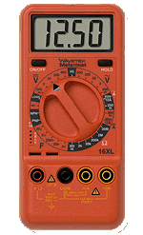
There are two types of ammeters that we will use in this class. They are known as analog and digital ammeters. To help keep them straight, think about analog and digital clocks. An analog clock is the type of clock with the second, minute, and hour hands. A digital clock is the type of clock that displays the time on a screen. Example 3:45. In this class, we will focus mainly on using analog ammeters as they are more readily available in our school. However, digital ammeters are becoming more popular so you should be familiar with how they work as well.

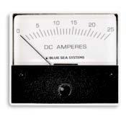
Analog
ammeter: Digital
ammeter:

How to read an analog ammeter:
As in any measurement, you should always read the smallest division on your scale, and then estimate the next digit.
For Example:
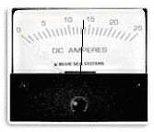

Current measurement: 13.4 A or 13.5 A

NOTE: Everyone will not likely obtain exactly the same measurement. Therefore, as long as your estimate for the last digit is reasonable it will be considered to be correct.

Let’s do a few together on the overhead.

Now, let’s practice on our own!

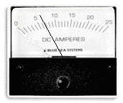
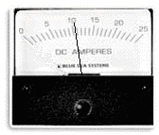

Current measurement: Current measurement:

How to read a digital ammeter:
Unlike the analog ammeter, once you have a measurement on your digital ammeter, it is very simple to read. All you need to do is read the number on the display screen and use the correct units, depending on the dial setting you have chosen. You will have an opportunity to try using a multimeter at least once during the class activity, under teacher supervision.

The digital ammeter we will use in class is actually a multimeter so this instrument is capable of measuring more than just current. The difficult part of using a multimeter lies in selecting the correct settings. We will go through an example of how to choose the settings on a multimeter together as a class. Throughout this demonstration, you should refer to your handout titled ‘Multimeter.’ The important ideas will be discussed in class. Use the following space to record the information:

How to set up an ammeter:
In order for an ammeter to accurately measure current, it needs to be placed in series in the circuit. To begin, you should first set up your circuit as necessary, without including the ammeter. The steps for placing an ammeter in a circuit are as follows:

Step 1: Break the circuit in the desired location. This involves physically disconnecting a wire or component to make a place for the ammeter in the circuit.

Step 2: Connect the red and black leads to the ammeter. The black lead will always go to the negative/grounded terminal. The red lead will go to the positive terminal on the ammeter.

Step 3: Connect the ammeter to your circuit. The black lead should always be connected to the side of the circuit that is closest to the negative terminal of the power source. The red lead should always be connected to side of the circuit that is closest to the positive terminal of the power source. If you fail to do this correctly, the ammeter may be damaged.
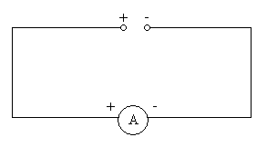

red lead
black lead

Before we begin the activity, you will have a chance to practice setting up a circuit that includes an ammeter, using a circuit diagram as your guide.

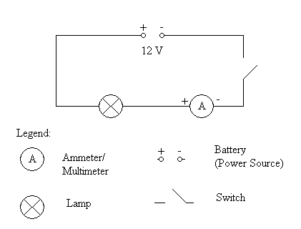
With a partner, set up the following circuit. The teacher will come around to ensure you have set up the circuit correctly and will be available to answer any questions.

Multimeter (Digital ammeter)

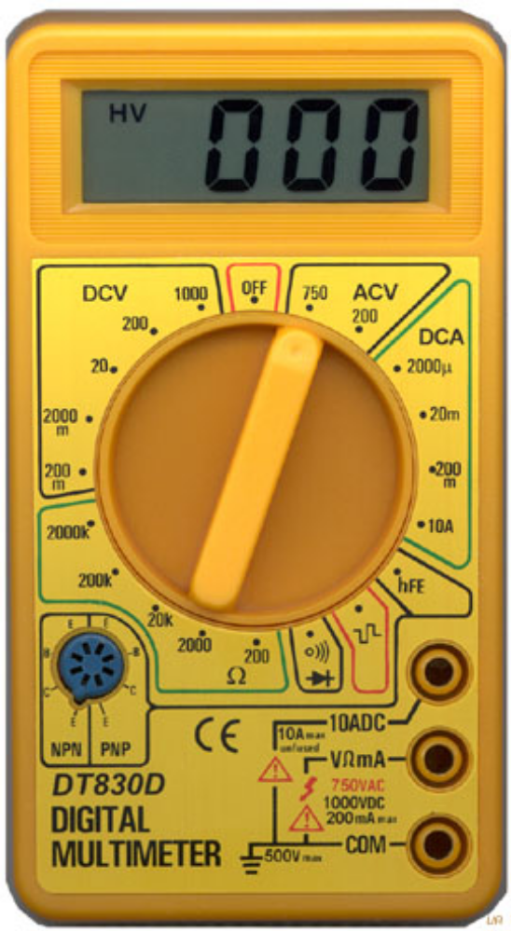

Display Screen
Black Lead (Ground Plug-in)
Off Switch
DC Current Area
Red Lead Plug-ins
Dial

Circuits and Current Activity (aka How to Use an Ammeter)

In this activity you will learn how to measure the current flowing in circuits using an instrument called an ammeter. As we discussed in class an ammeter measures the size of current using a unit called the ampere (A). Using an ammeter you will investigate how the size of a current varies in circuits with
- one resistor;
- two identical resistors in series;
- two identical resistors in parallel.

The resistors in the following experiment will be 12 V light bulbs.

Note: Always connect the red (+) terminal on the ammeter to the positive terminal on the power supply. If there is more than one range, start with the biggest (least sensitive) range.

Aim:
- To be able to read an ammeter to obtain a value for current
- To be able to appropriately place an ammeter in a circuit
- To investigate the size of current in different parts of parallel and series circuits

Equipment needed:
Battery, connecting wires, a switch, an ammeter, two 12 V lamps

Method:
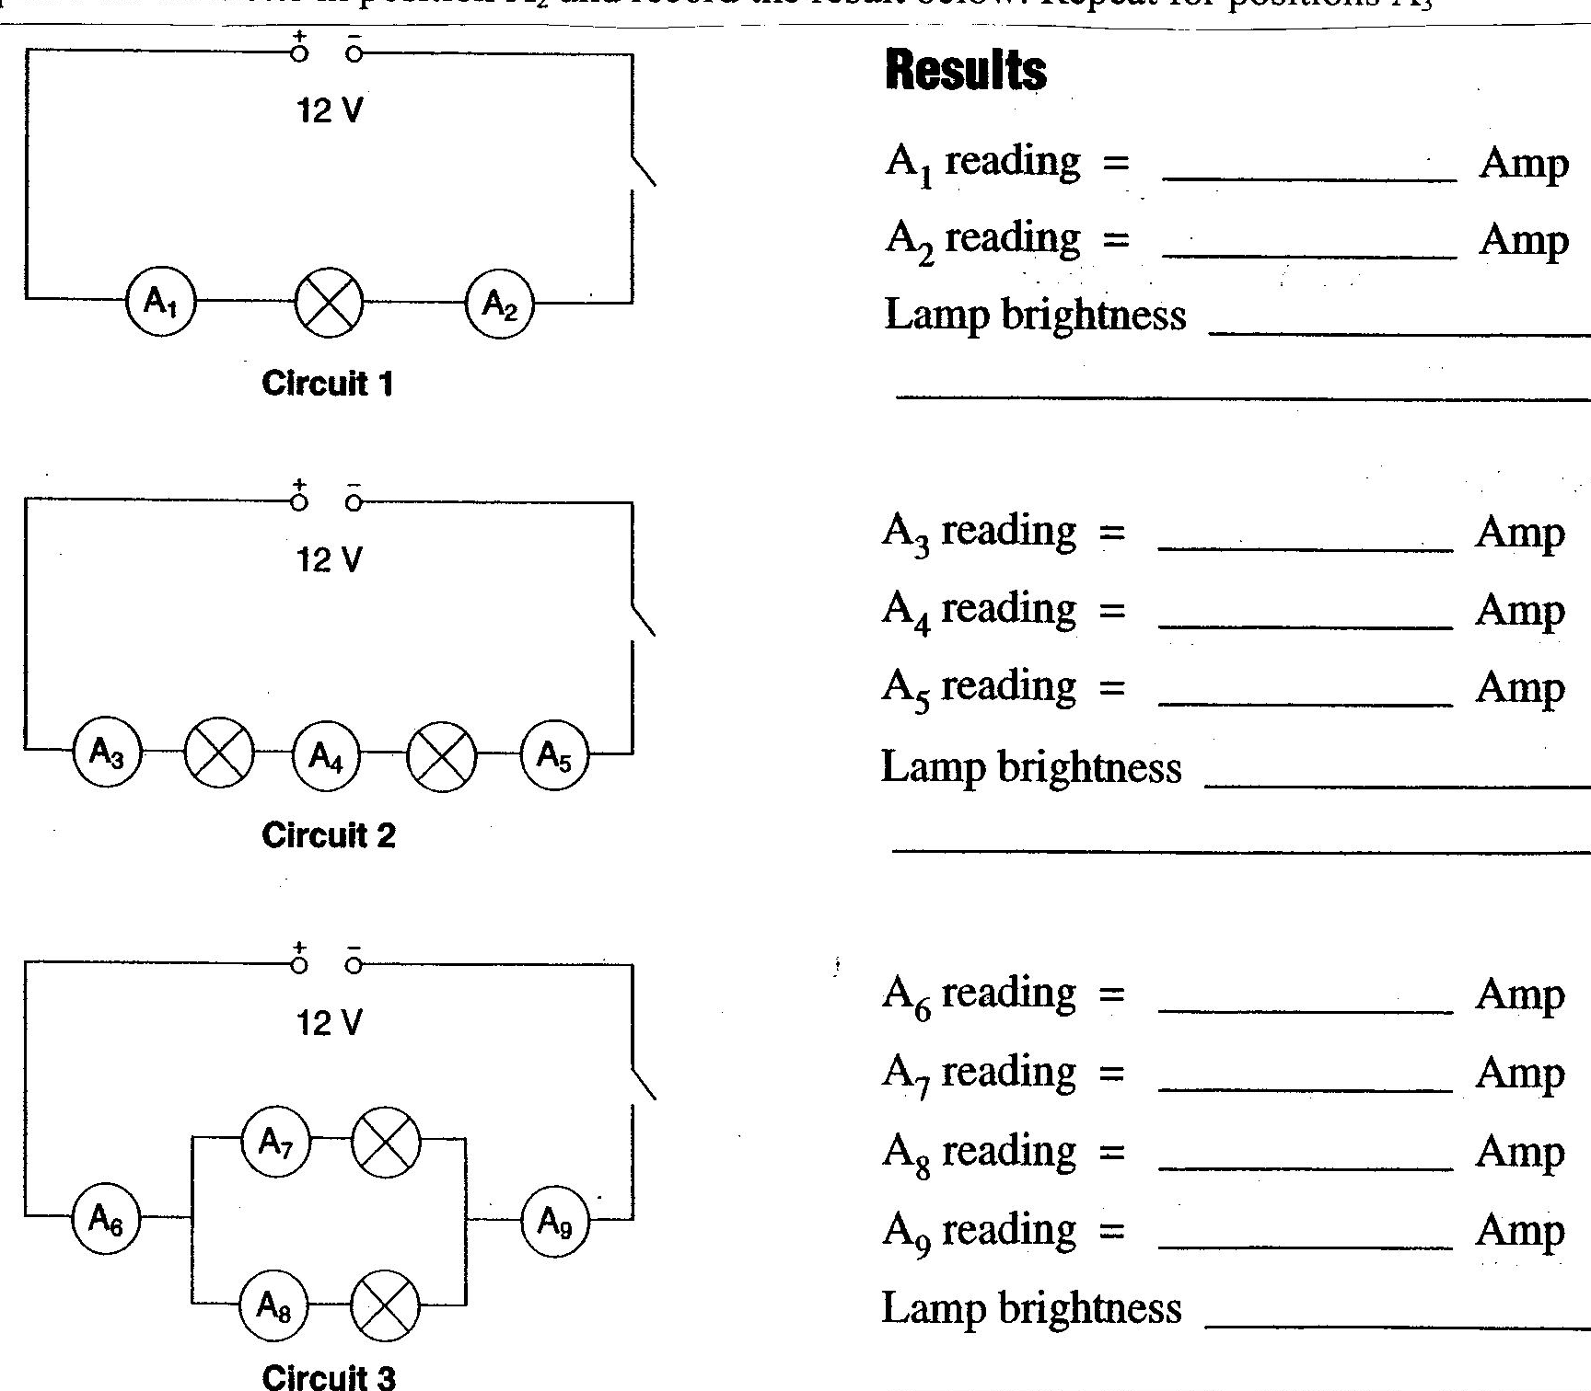
Set up each of the circuits as shown in the circuit diagrams below and measure the current with the ammeter by placing the ammeter first in the position A₁. Record the current at position A₁ below. Now place the ammeter in position A₂ and record the result below. Repeat for positions A₃ through A₉.

Comparing Circuits

Series Circuit:
- In Circuit 1 compare the size of the current before and after the lamp.

- In Circuit 2 compare the size of the current in different parts of the circuit.

- How do the brightness of the lamps in Circuits 1 and 2 compare?

- In Circuit 2 what difference does the extra lamp make to the size of the current compared to the current in Circuit 1?

Parallel Circuit:
- How does the brightness of each lamp in Circuit 3 compare with the lamp in Circuit 1?

- Describe what is happening to the current as it enters the parallel parts of the circuit and as it leaves.

- Compare the size of the total current in Circuit 3 compared to that in Circuit 1.

- What are some of the advantages of Circuit 3 compared to Circuit 2.

Extension:
Does including the ammeter in the circuit have an effect on the current that is being measured? Explain.

Summary:
In your notebook, write a statement or construct a chart to summarize the differences in the brightness and current flow through the bulbs in a series circuit compared to a parallel circuit.

Be prepared to discuss your findings in class.
Clarification will be provided from the teacher, if needed.

